Evaluation: ET-OvR
Accuracy: 0.9464
Precision: 0.946601525198827
Recall: 0.9464
F1 Score: 0.9462308816196928
Jaccard Index: 0.8990510007965294
Matthews CorrCoef: 0.933129527368222
Cohen’s Kappa: 0.933
Specificity: 0.9865999999999999
AUC: 0.994809
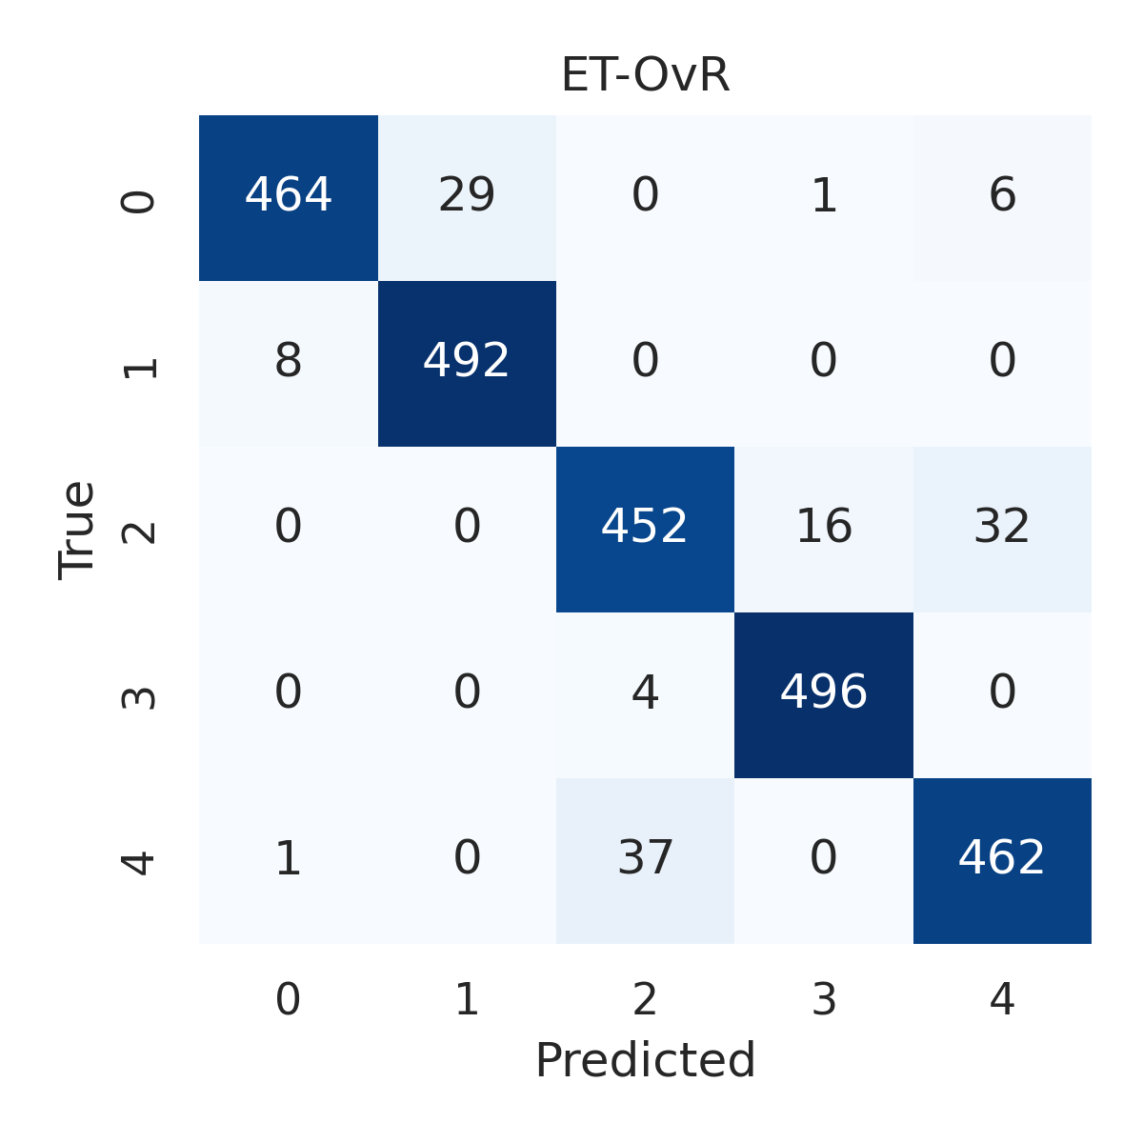

Combined ROC Curves
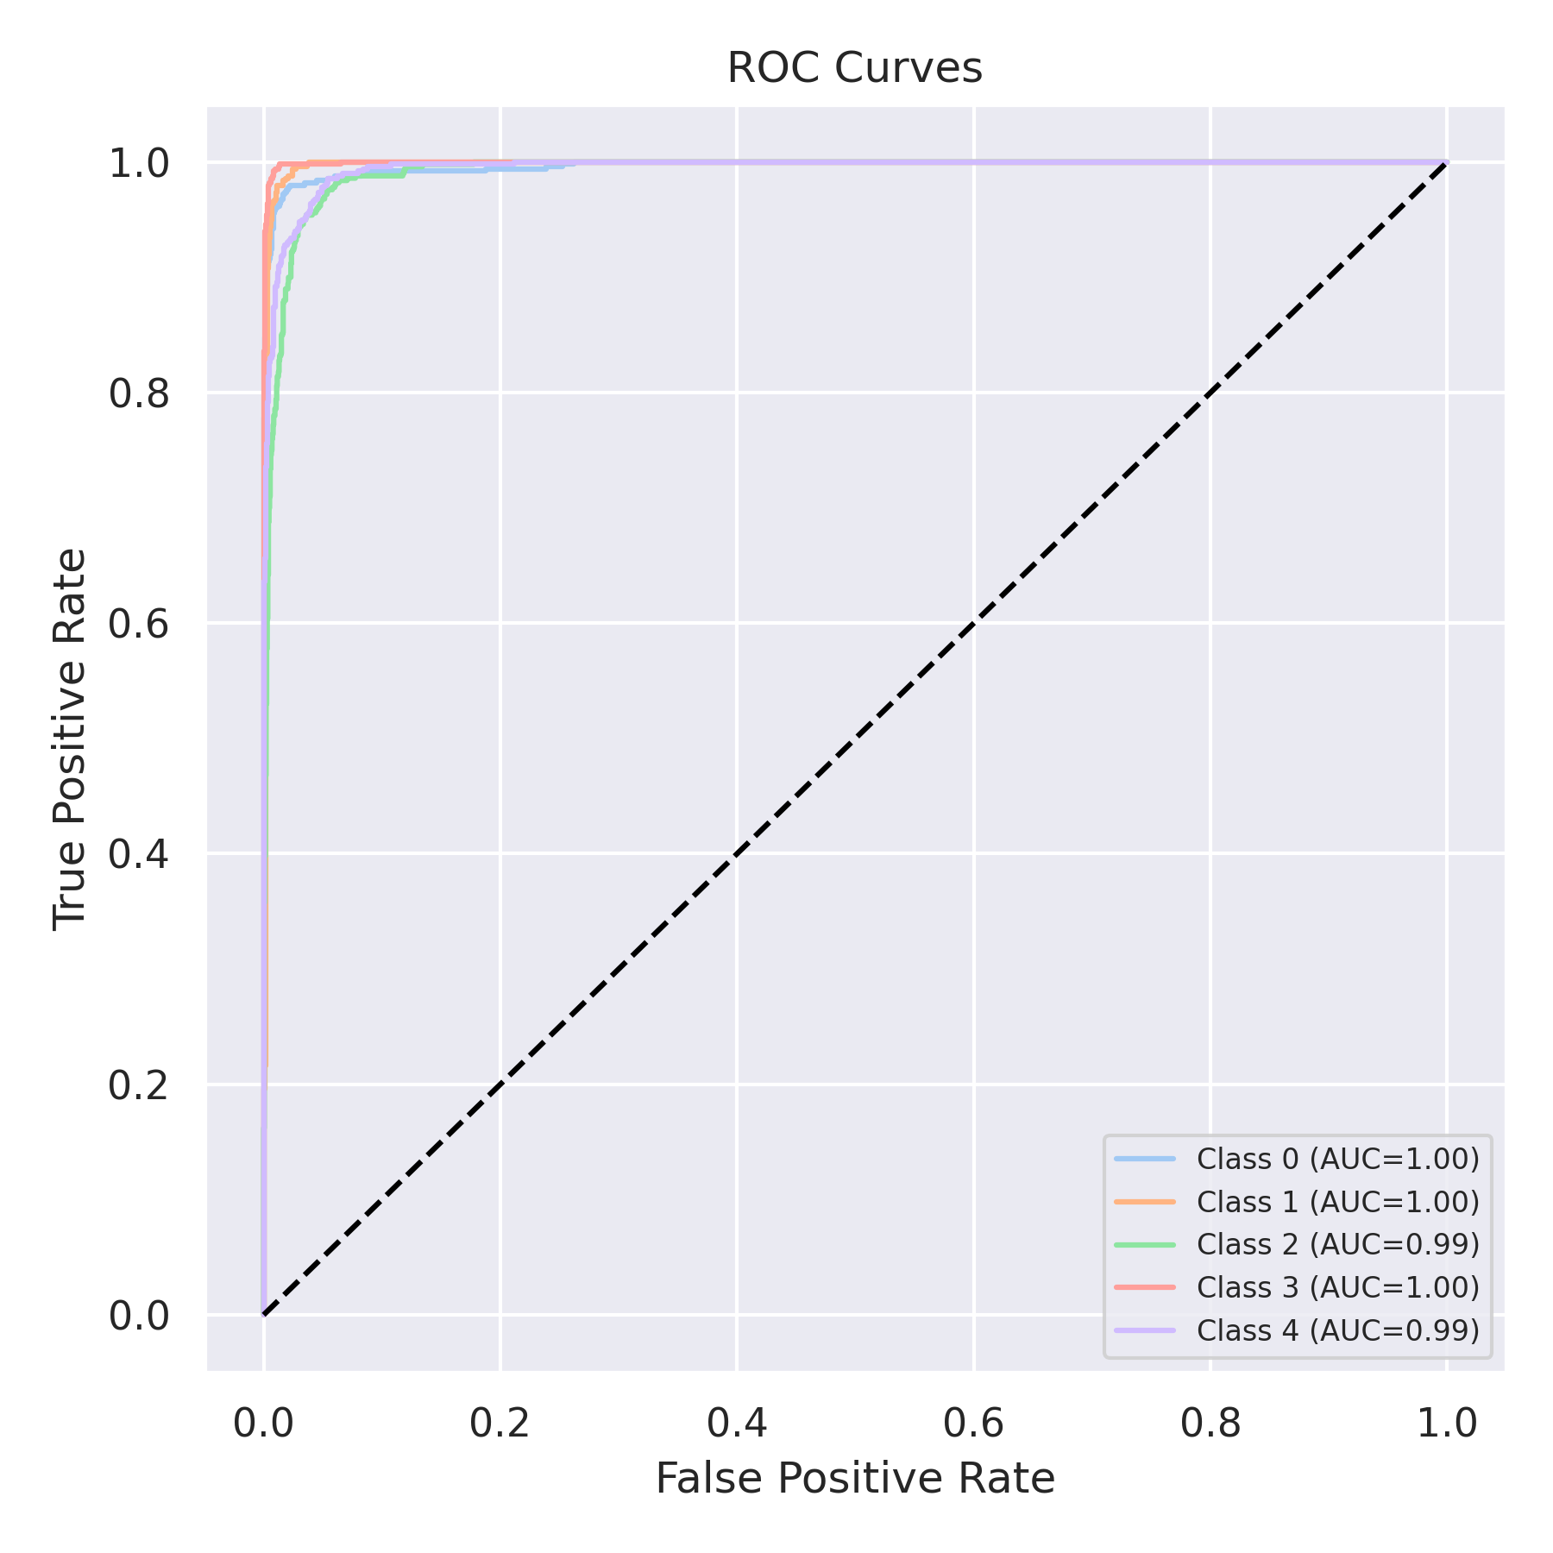

Evaluation: RF-OvR
Accuracy: 0.9388
Precision: 0.9387946371923197
Recall: 0.9388
F1 Score: 0.9386646762385346
Jaccard Index: 0.8858401206000069
Matthews CorrCoef: 0.9235633586196765
Cohen’s Kappa: 0.9235
Specificity: 0.9846999999999999
AUC: 0.993938
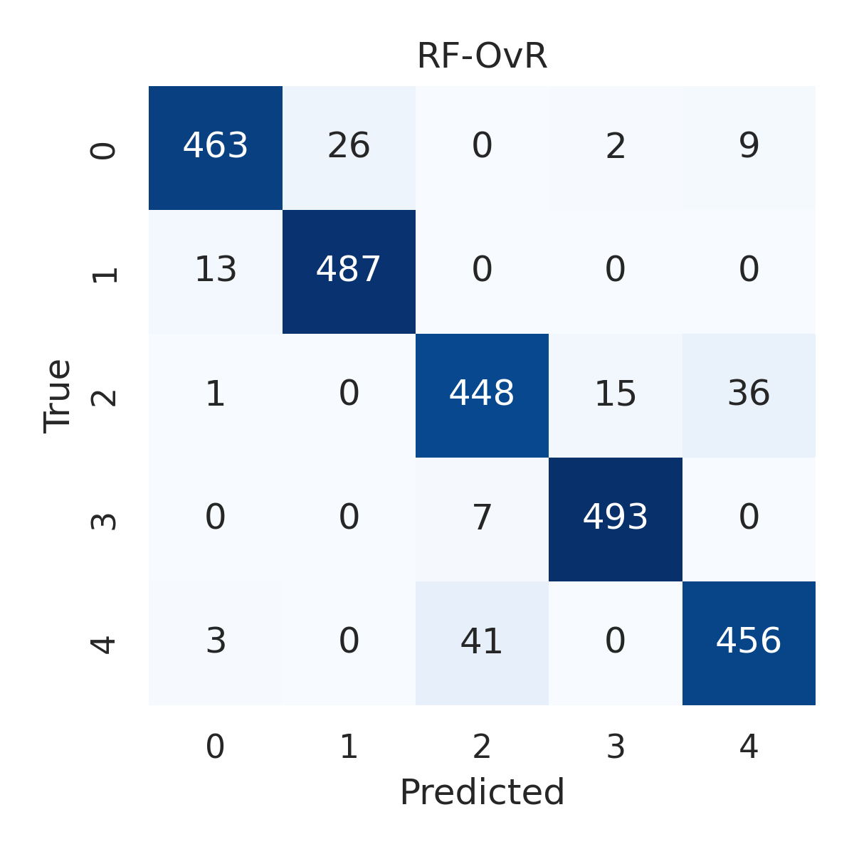

Combined ROC Curves
